**Report about conducted load test**

**Date:** 04/07/2022

**Author:** Vladyslav Kliucharov

**Application:** BlogEngine.NET version 3.2

**Environment:** Test Environment VirtualBox (Version 6.1.34 r150636 (Qt5.6.2))

**Test Environment configuration(RAM, CPU etc.):**

|  |  |
| --- | --- |
| **Processor** | 11th Gen Intel(R) Core(TM) i7-1185G7 @ 3.00GHz 3.00 GHz (4 core) |
| **RAM** | 8 GB |
| **Hard Disk** | 60 GB |
| **Operating System** | Windows 10 Enterprise (21H2) |

1. **Why such testing was conducted:**

The report is included two methods of testing:

1. Smoke testing - was conducted to verification that the crucial functions of a program can be run and executed in the main workflow

2. Scalability Testing- was conducted to define and ensure that the system can handle the scaling of CPU and RAM performance goals

1. **Test script description:**

The features to be tested have been logically grouped to be covered by 3 threads of users "Admin script", "Editor script" and "Anonymous script". These scenarios were combined in one script followed by load requirement analysis for the modules. The below table captures the features covered by each script. The implement probabilities usage was divided by percentages for all threads (shown below tables):

|  |  |
| --- | --- |
| **Admin script** | **Editor script** |
|  |  |

|  |  |  |
| --- | --- | --- |
|  | **Anonymous script** |  |
|  | |  | | --- | | 1. Home Page: 15%  2. Open Random Date: 10%  3. Open Predefined Date: 30%  4. Search by Name: 30%  5. Open Large Calendar: 10%  6. Open Contacts: 5% | | |  | | --- | | 1. Open Random page (yes/no): 50% / 50%  2. Open post (yes/no): 80% / 20%  3. Random or First (yes/no): 65% / 35%  4. Comment (yes/no): 20% / 80% | |

1. **Tests:**  
   **Test run preconditions:**

* CSV file with Random dates
* Warmup script was running before each test run
* Before each new test script run, the webserver was reloaded, the test executed in NON-GUI mode

|  |  |  |  |  |  |
| --- | --- | --- | --- | --- | --- |
| **Thread Group** | **Maximum number of simultaneous users** | **Ramp-Up period** | **Test duration** | **Probabilities usage** | **Number of posts quantity** |
| Thread Group (Admin users) | 2 | 200 | 800 (sec.) | Pre-Defined | 1000 |
| Thread Group (Editor users) | 10 | 100 | 800 (sec.) | Pre-Defined | 1000 |
| Thread Group (Anonymous users) | 70 | 700 | 800 (sec.) | Pre-Defined | 1000 |

1. **Short summary on conducted tests:**

For scaling test will use

1. **Detailed test results:**

‘Blended_Task4_Task5_Task6’ scripts were running 3 times, according to the capacity testing results, the comfort zone and behavior has a different result:

1st run is showing a saturation point is approximately 78 users and the comfort zone is 10 users. Degradation of successful queries starts after the 78th user. Total requests 5890, failed requests 495.

2nd run is showing a saturation point is approximately 70 users and the comfort zone is 10 users. Degradation of successful queries starts after the 70th user. Total requests 5960, failed requests 477.

3rd run is showing a saturation point is approximately 83 users and the comfort zone is 10 users. Degradation of successful queries starts after the 83rd user. Total requests 5577, failed requests 417.

**Test Run #1**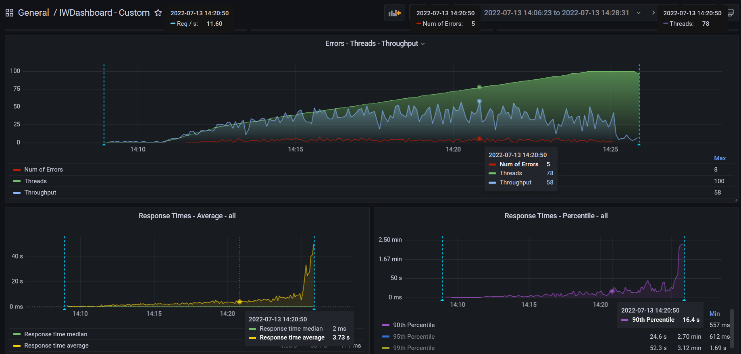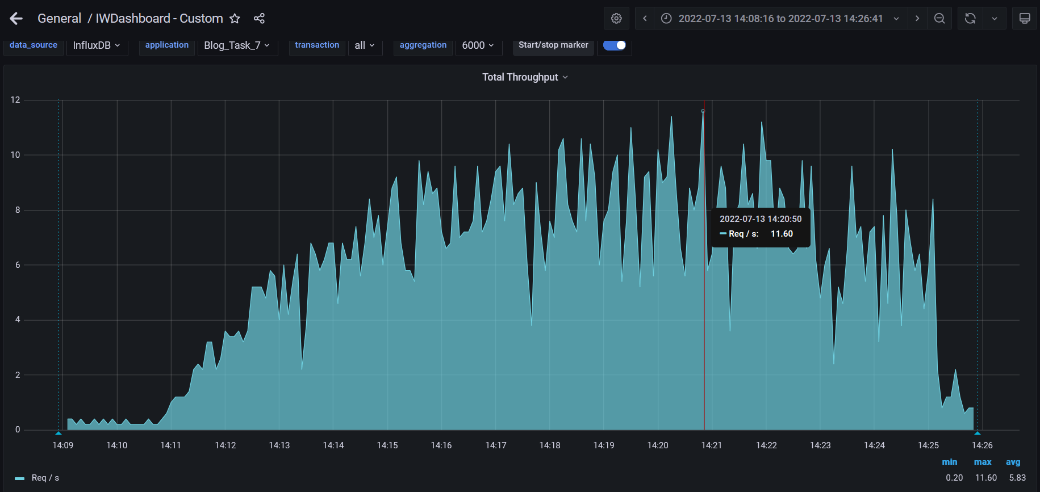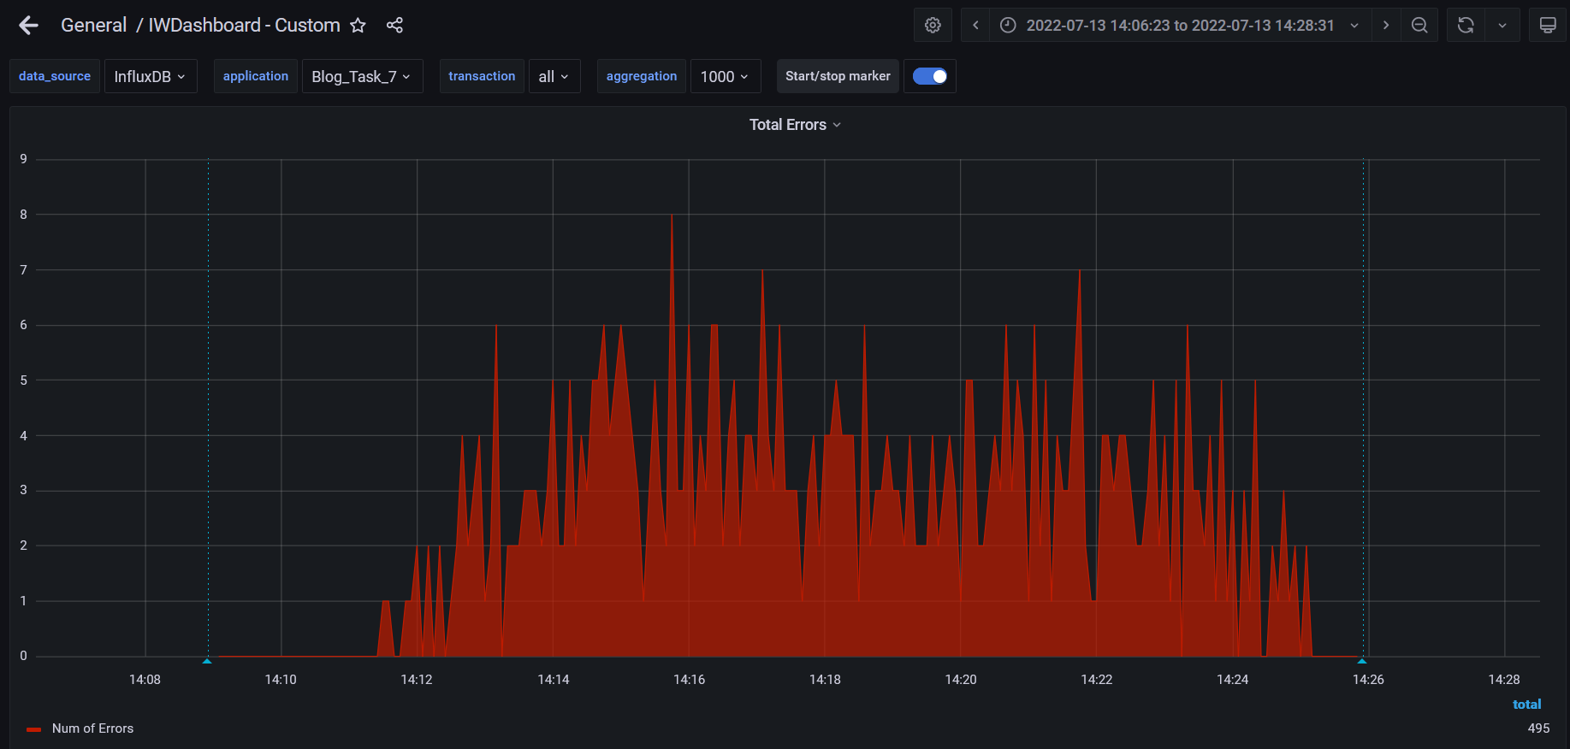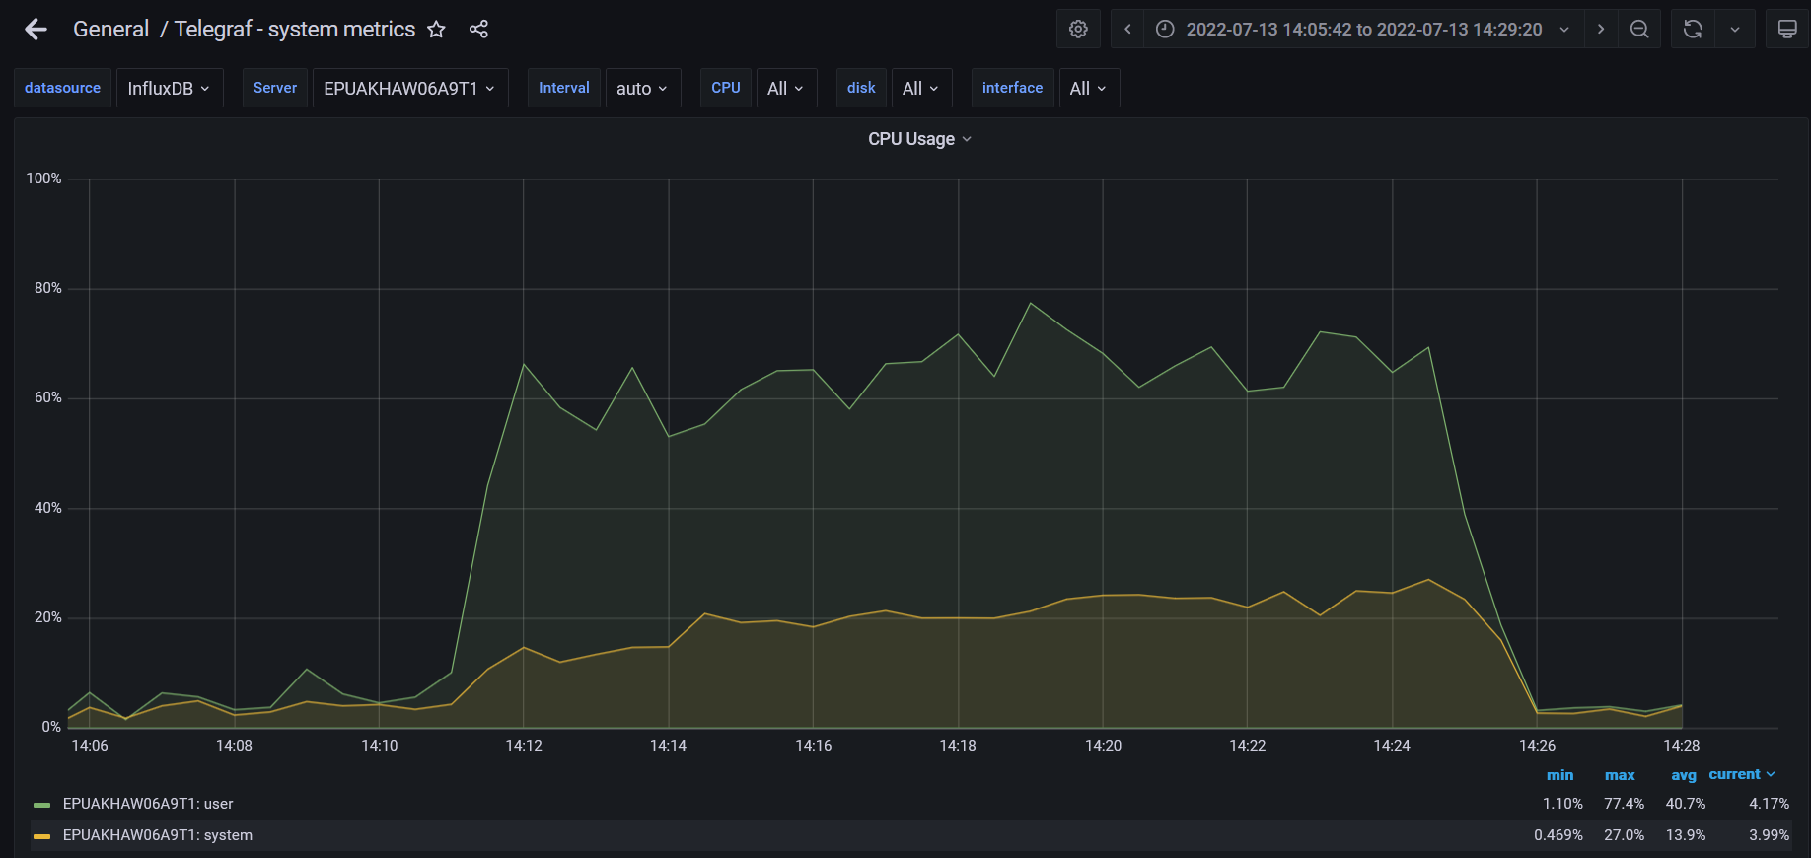

**Test Run #2** 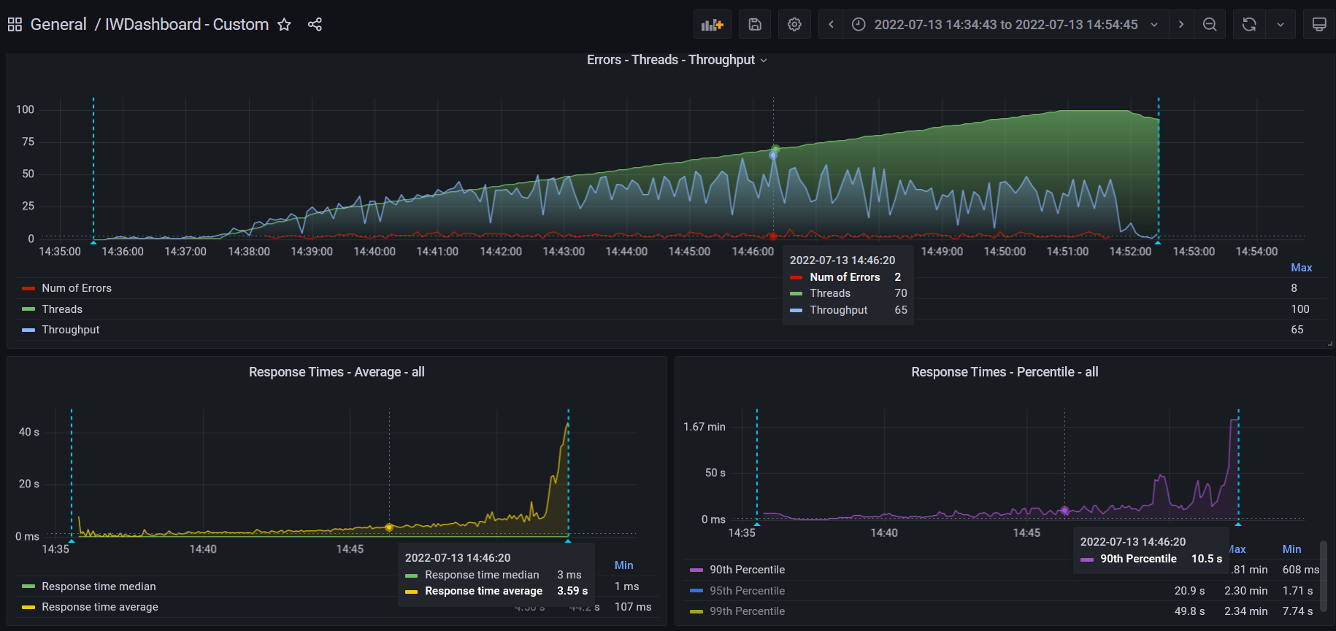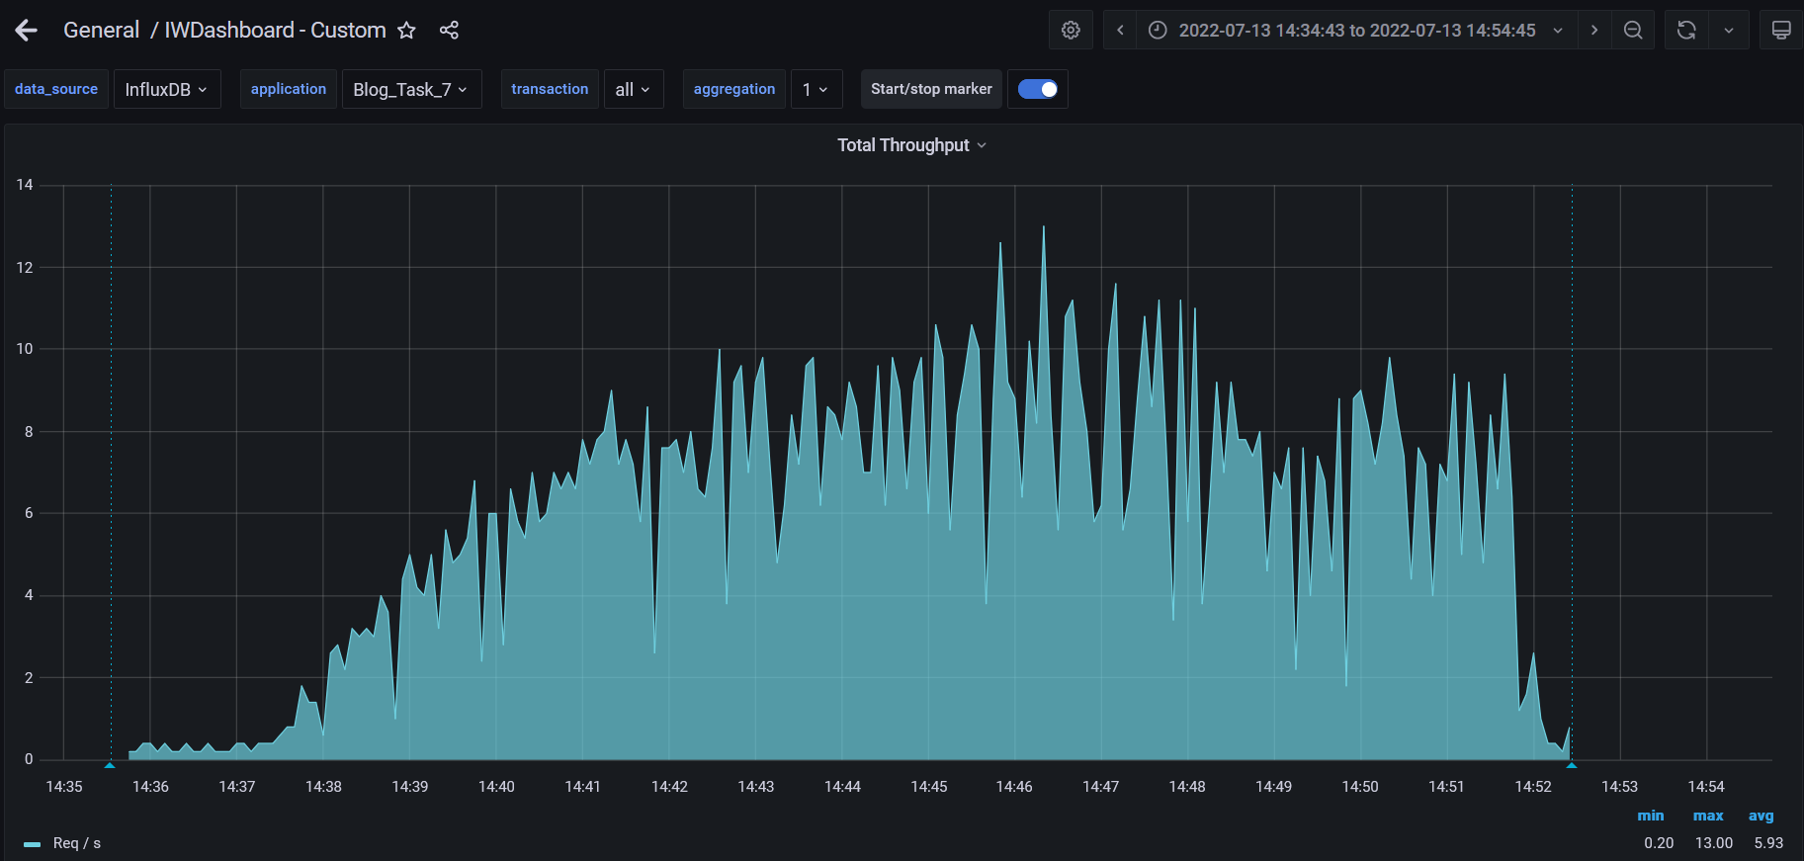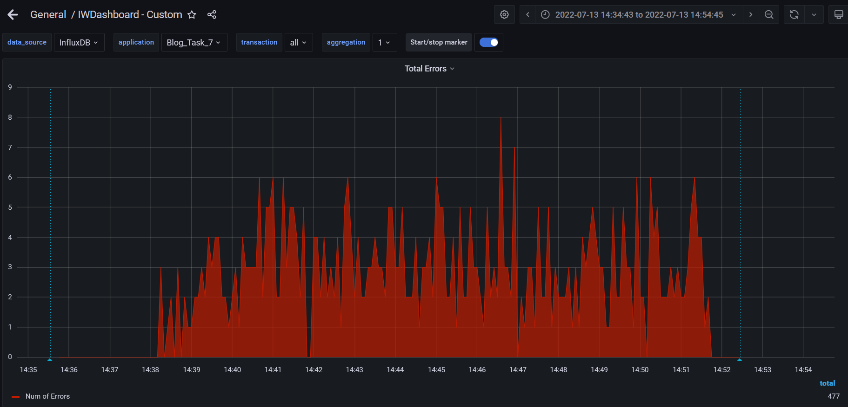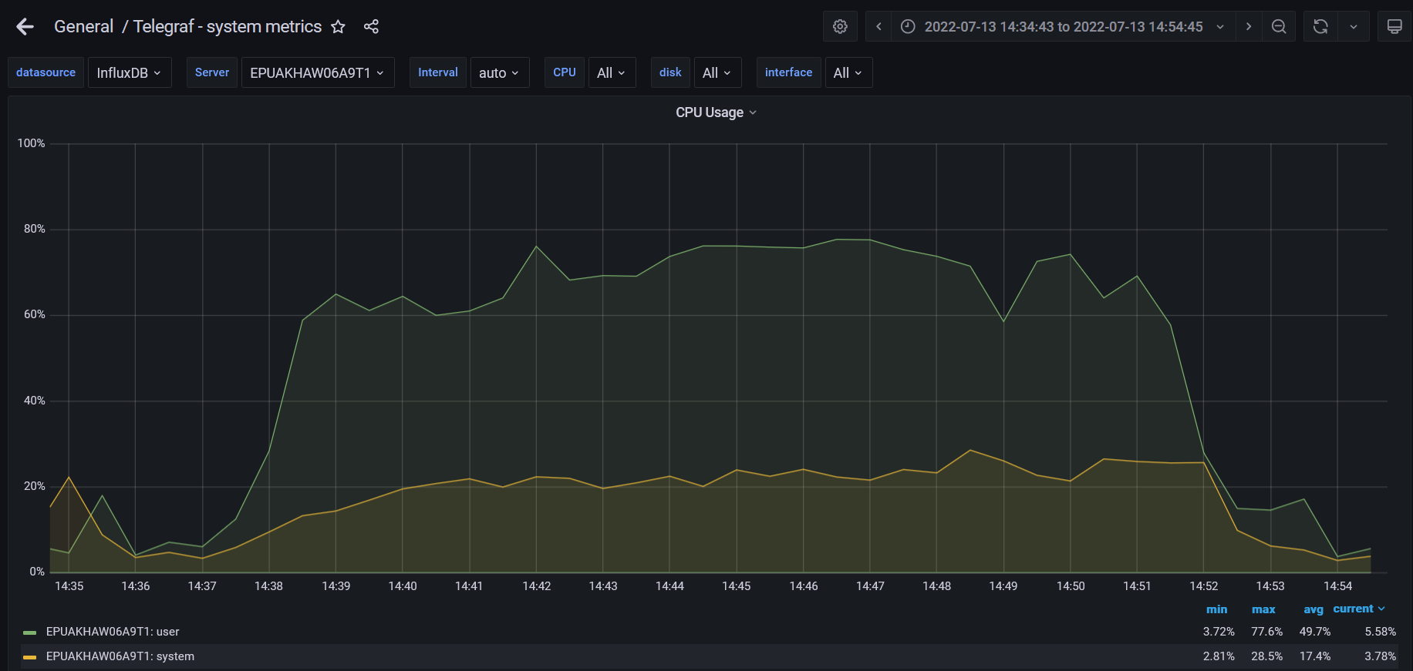

**Test Run #3**

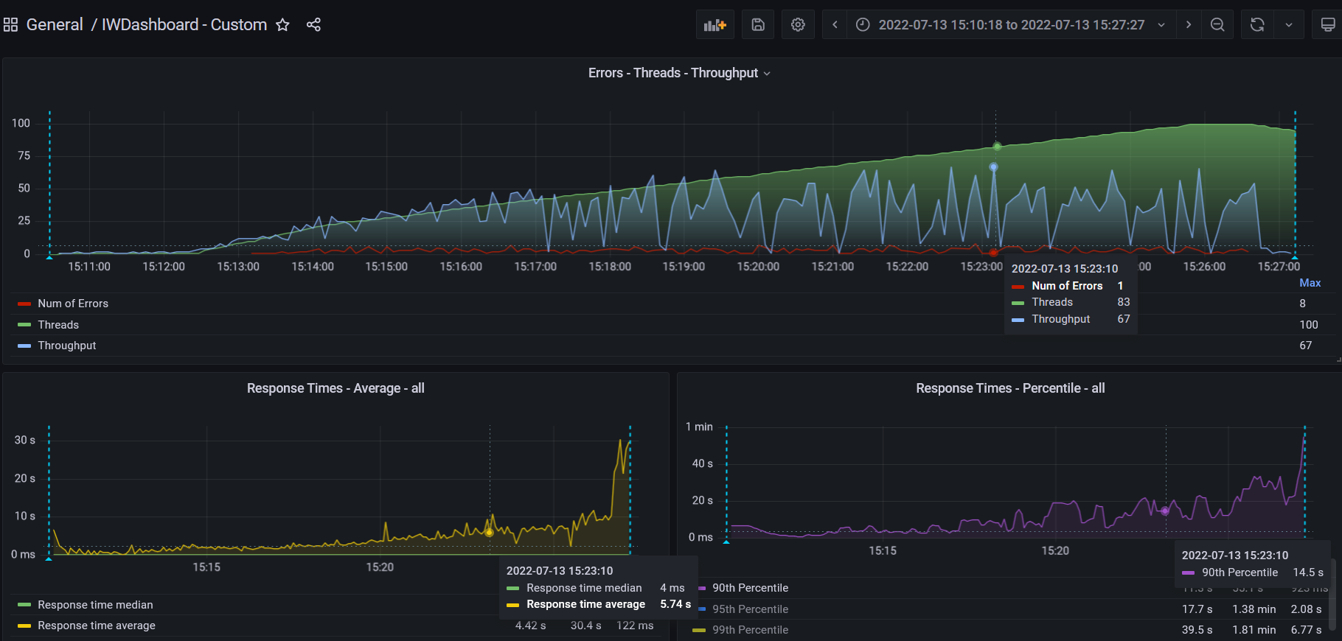

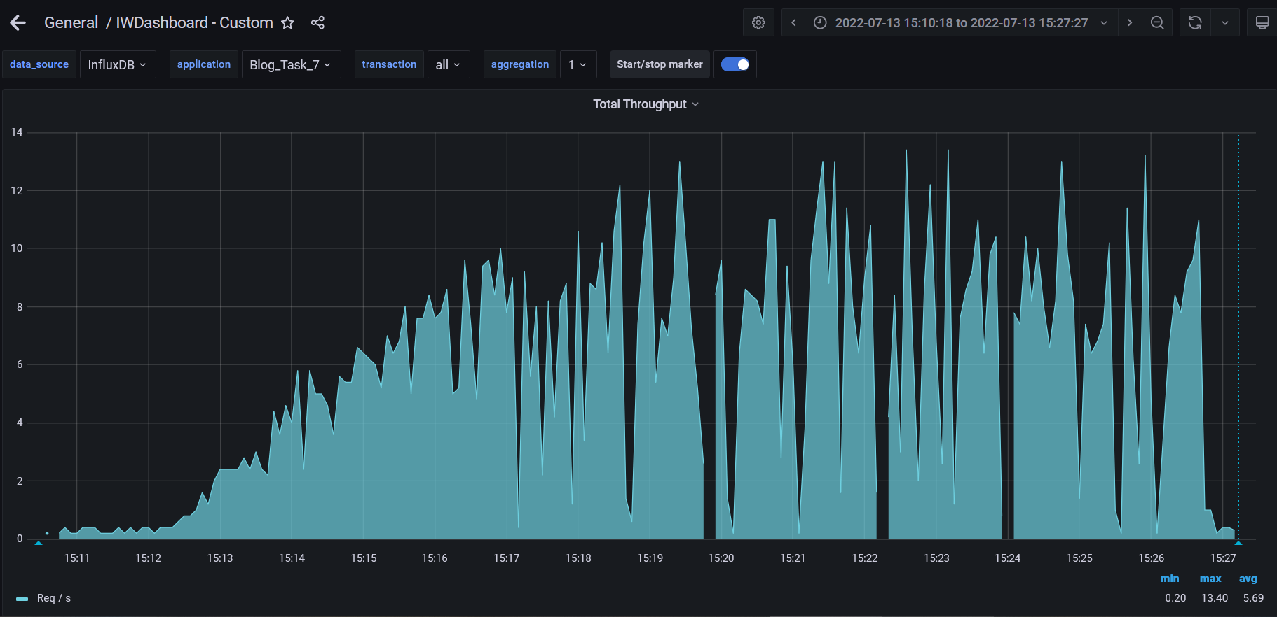

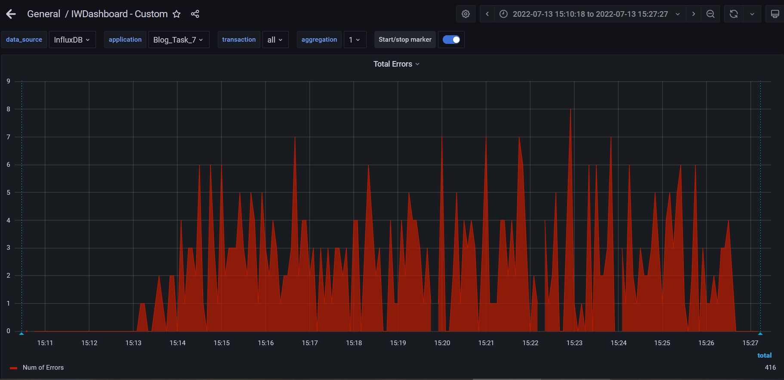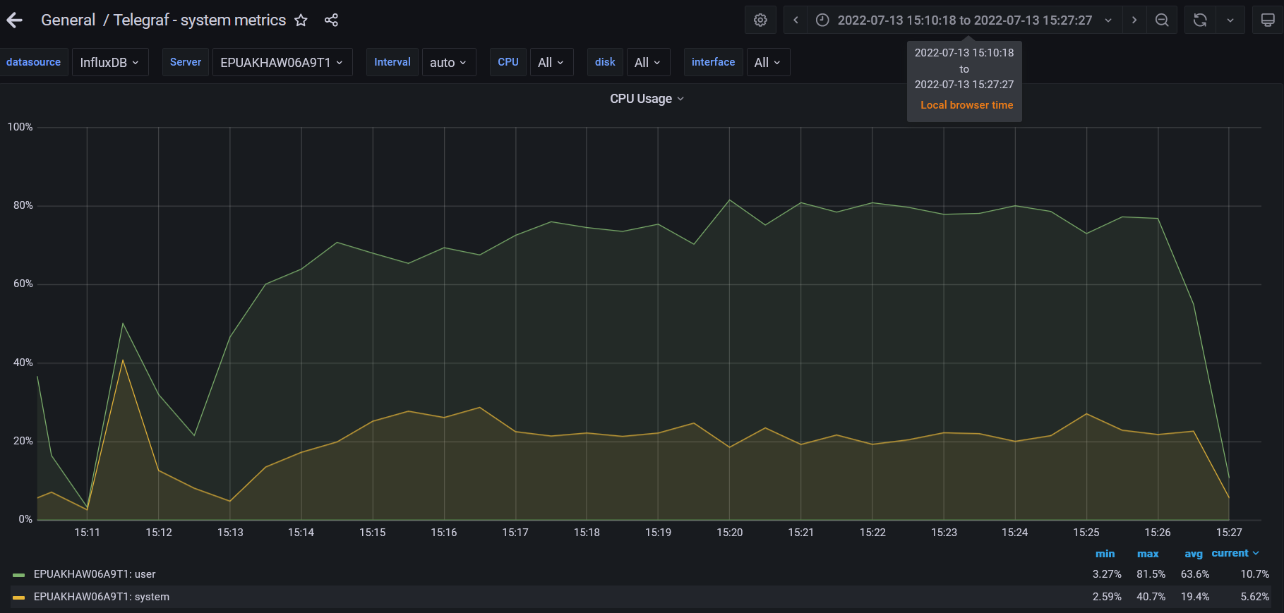

1. **Conclusion:**

The server worked stable according to the received data test results, maximum CPU was filled on 80%.

Error info by 3 runs:

The error 500:

|  |  |
| --- | --- |
| **Transaction** | **Error sum** |
| Transaction Controller (Search By Name) | 7 |
| Transaction Controller (Save Post) | > 1k |
| Transaction Controller (Open RandomDate) | 9 |
| Transaction Controller (Open PredefineDate) | 25 |
| Transaction Controller (Open Post) | 2 |
| Transaction Controller (Open Large Calendar) | 9 |
| Transaction Controller (Open Home Page) | 1 |
| Transaction Controller (Open Home Page Anonymous) | 17 |
| Transaction Controller (Open Date) | 1 |
| Transaction Controller (Open Contacts) | 3 |
| Transaction Controller (Add User) | 1 |

The 404 - errors is 0.84%